DSA 502- Data Science with AI
Abu Hanif
Instructor: Prof. Dr. Joaquin Carbonara
AI-Powered Personalized Nutrition Recommendation System (Project Report)
1. Executive Summary
This project presents the design and development of an AI-Powered Personalized Nutrition Recommendation System (PNRS) that combines machine learning, nutrition analytics, recipe intelligence, and future dashboard integration to support personalized food decision-making. The system was designed around three core goals: predicting calorie needs, recommending nutritionally appropriate foods and meals, and building an interactive dashboard for end-user interpretation and decision support.
AI-Powered PNRS: The project uses three connected datasets. The first dataset contains physiological and exercise-related variables used to predict calorie expenditure. The second dataset contains food-level nutrition facts, which power the food recommendation engine. The third dataset contains recipe information used to extend the system from ingredient-level recommendations to meal-level suggestions. This design transforms the project from a basic regression exercise into a broader AI application that links prediction, ranking, and explainable nutrition support.
AI-Powered PNRS: A full workflow was completed, including project overview, data card, data loading, audit, cleaning, sanity checks, exploratory data analysis, feature engineering, model development, model comparison, explainability, and recommendation logic. During refinement, an important modeling issue related to target leakage was identified and corrected, resulting in more realistic calorie predictions and stronger methodological validity. That correction significantly improved the practical value of the recommendation engine.

2. Project Objective and Research Direction
The purpose of this project is to build a data-driven system that can estimate calorie needs from user characteristics and exercise variables, then use that estimate to recommend foods and recipes aligned with the predicted calorie range and nutrition quality.
The project was guided by three main research questions. First, can physiological and activity-related variables be used to accurately predict calories burned? Second, can nutrition datasets be converted into a recommendation engine that identifies foods aligned with user needs? Third, how can data visualization and dashboarding improve interpretability, usability, and trust in AI-driven nutrition recommendations?
This framing is important because it aligns the project with both academic machine learning expectations and real-world AI application design. Rather than stopping at prediction, the system translates model output into personalized decision support, which is much closer to how AI systems are evaluated in practice.

3. Data Sources and Dataset Roles
The project integrates three datasets with distinct analytical roles.
The exercise-calorie dataset serves as the predictive modeling foundation. It includes variables such as user ID, gender, age, height, weight, exercise duration, heart rate, body temperature, and calories burned. After merging the exercise and calorie tables, the final calorie prediction dataset contained 15,000 rows and 9 columns, with no missing values and no duplicate rows. This made it a strong candidate for regression modeling.
The food nutrition dataset serves as the recommendation backbone. After combining five food groups, the dataset contained 2,395 foods and 37 columns before reduction. It includes food name, caloric value, fat, saturated fats, carbohydrates, sugars, protein, dietary fiber, sodium, vitamins, minerals, and nutrition density. Two unnecessary index columns were identified and removed during cleaning.
The recipe dataset serves as the meal-level extension layer. It includes recipe name, cuisine, ingredients, cooking time, prep time, servings, calories per serving, and dietary restrictions. The dataset contained 161 recipes and 8 columns. Only small amounts of missing values were present in servings and calories per serving, both of which were handled during cleaning.
Together, these datasets support a full AI pipeline: user inputs drive calorie prediction, calorie prediction drives food and recipe selection, and the dashboard layer will present these results visually.

4. Data Audit and Initial Quality Assessment
The audit phase showed that the calorie modeling dataset was unusually clean. All core variables were complete, correctly typed, and free of duplicate rows. The gender variable was balanced, with female and male observations nearly equally represented. This reduces the risk of strong class imbalance effects in model interpretation.
The food dataset was nutritionally rich but structurally noisy. The presence of Unnamed: 0 and Unnamed: 0.1 indicated spreadsheet export artifacts rather than meaningful variables. These were removed. The dataset also showed wide numeric ranges, with some food items having extremely high values in calories, protein, cholesterol, or micronutrients. This does not automatically mean the dataset is wrong, but it does suggest that some foods are concentrated, processed, or highly dense products, which should be considered during recommendation ranking.
The recipe dataset was smaller and more curated, but it required careful treatment of dietary restrictions, where many rows contained placeholder values like ['nan']. Missing values in servings and calories per serving were limited and manageable.
The audit phase was valuable because it established that the project datasets were usable, but not uniformly so. Each dataset required a different cleaning strategy.

5. Data Cleaning and Sanity Checks
Cleaning focused on making the datasets analytically consistent and suitable for machine learning and recommendation.
For the calorie dataset, columns were standardized to lowercase, and sanity checks confirmed realistic ranges for age, height, weight, duration, heart rate, body temperature, and calories. Calories ranged from 1 to 314, which is plausible for short exercise sessions. Exercise duration ranged from 1 to 30 minutes, which fits the observed calorie targets.
For the food dataset, unnecessary index-like columns were removed, and core variables were renamed into modeling-friendly names such as calories and fiber. A reduced nutrition table was created containing food, calories, protein, fat, carbohydrates, sugars, fiber, sodium, and nutrition density. This reduction was important because recommendation systems work better with relevant nutrition variables than with an unnecessarily large number of micronutrient columns.
For the recipe dataset, missing values in servings and calories per serving were imputed using median values, and the dietary restrictions field was standardized by replacing placeholder values with a more interpretable category such as "none".
These cleaning steps prepared the data not only for statistical analysis but for downstream AI use, where clean feature logic matters more than raw file completeness.

6. Exploratory Data Analysis
EDA was a major part of the project because it helped reveal the structure of the data and supported later modeling decisions.
6.1 Calorie Dataset EDA
The gender distribution chart showed a balanced dataset, which is helpful because it means the model is less likely to be dominated by one gender group. This supports more stable regression learning.
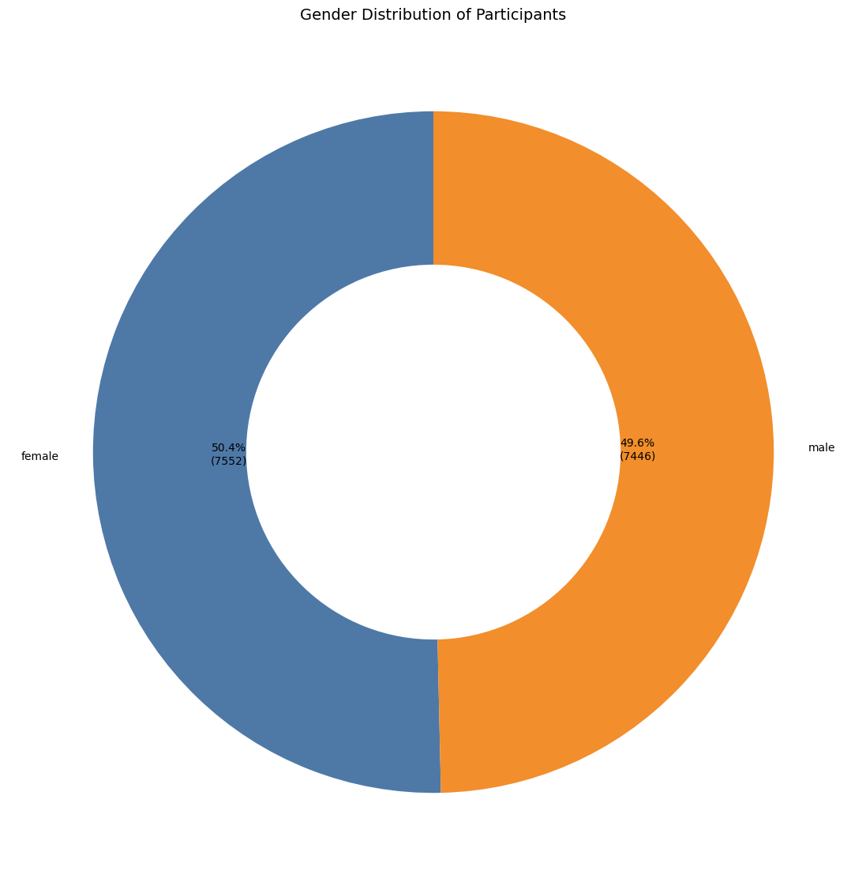
The age distribution histogram showed that the participants covered a broad adult range, from 20 to 79, with a mean around the early 40s. This means the model is being trained across young, middle-aged, and older adults rather than a narrow age band.
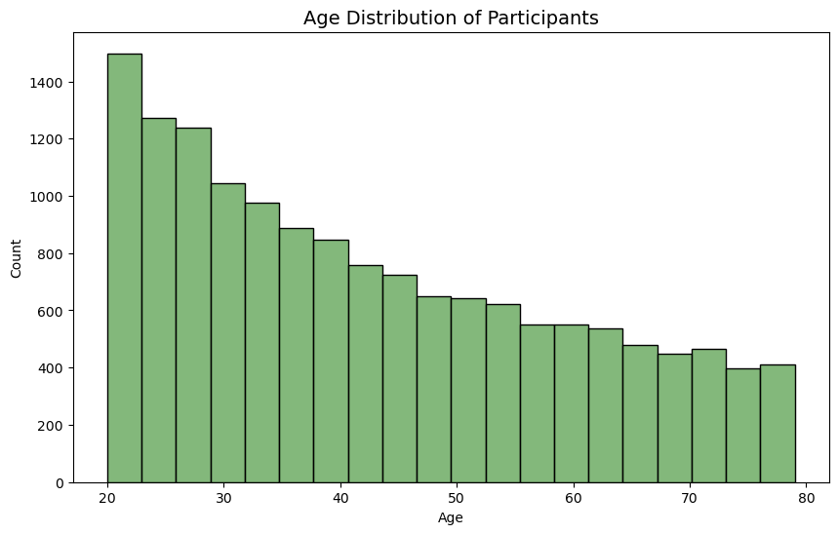
The calories distribution plot showed a right-skewed shape, which is expected because many short or low-intensity activities burn fewer calories, while fewer sessions produce high calorie burn.
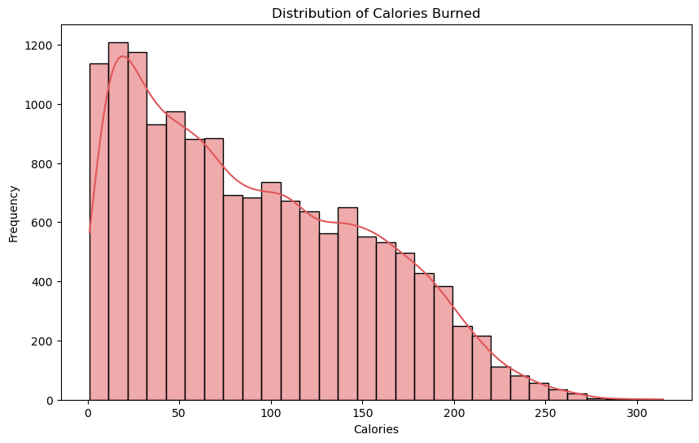
The Exercise duration versus calories plot was one of the most important visuals. It showed a strong positive relationship between exercise duration and calories burned. This result is intuitive and confirmed that duration would likely become one of the strongest predictive variables.
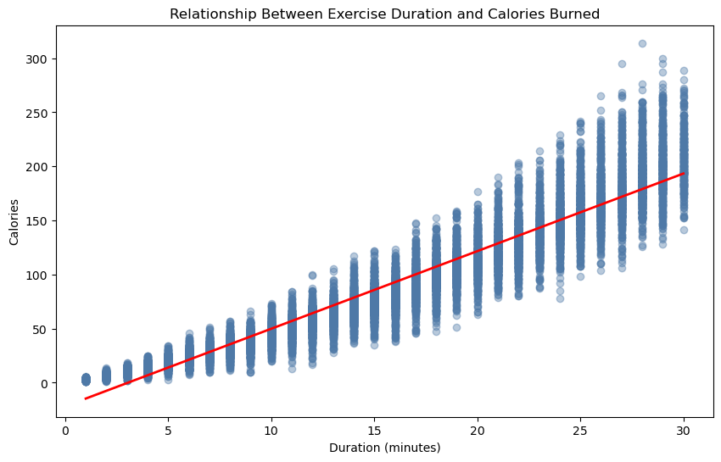
The heart rate versus calories bubble plot expanded this insight by showing that calorie expenditure tends to rise with both longer duration and higher heart rate. This supports the inclusion of heart-rate-derived features in the model.
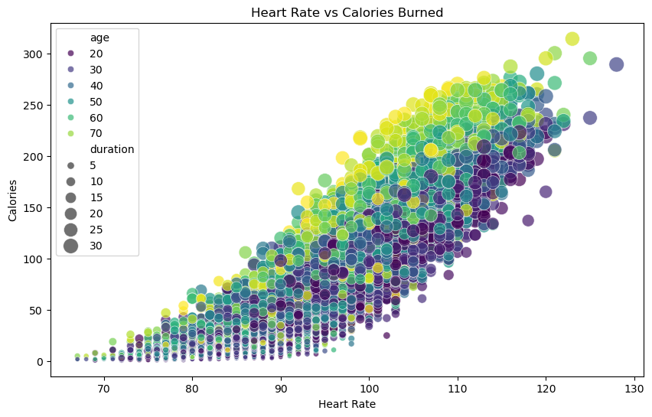
The correlation heatmap provided the clearest statistical summary. It showed that variables such as duration, heart rate, and body temperature have strong positive relationships with calories. This justified their use in regression modeling and helped confirm that the dataset contained real predictive signal.
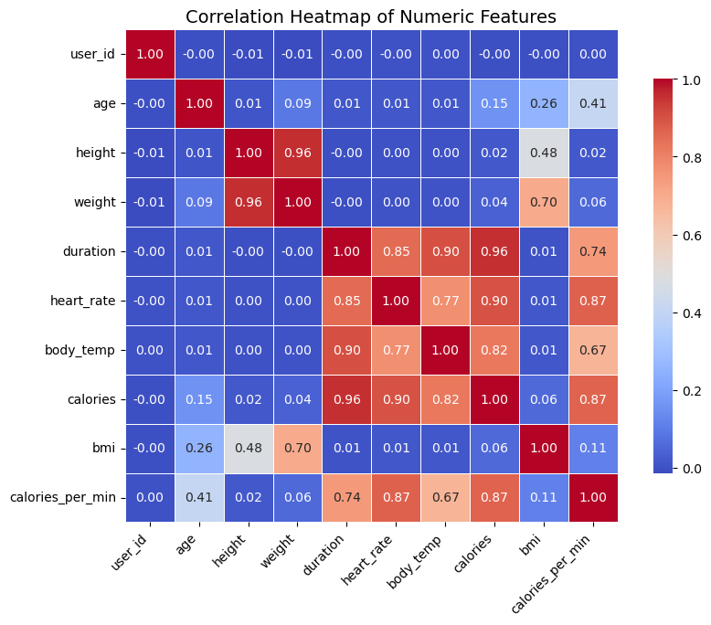
The 3D bubble plot for duration, heart rate, and calories offered a more advanced view of calorie generation. It visually demonstrated that higher calorie values occur where exercise duration and heart rate jointly increase. This chart is useful not only analytically but also for presentation because it captures multivariate structure in one figure.
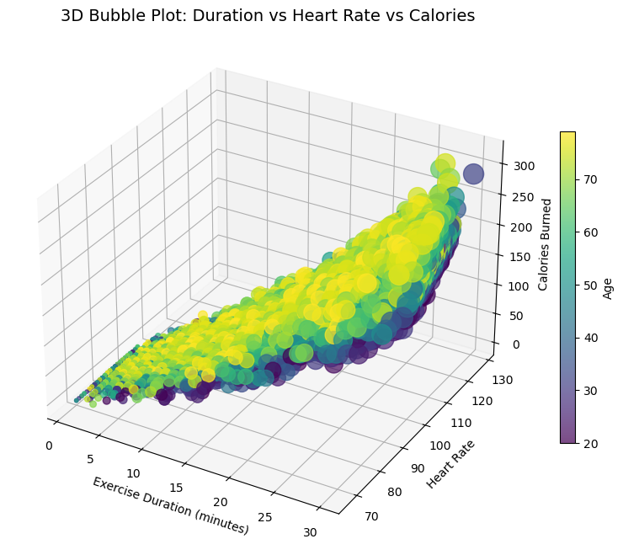
6.2 Food Nutrition Dataset EDA
The nutrition analysis moved the project from general ML into applied nutrition intelligence.
The high-protein foods chart identified foods that deliver unusually large protein values within moderate calorie ranges. This chart is directly relevant to recommendation because protein density often plays a major role in satiety and fitness-oriented nutrition.
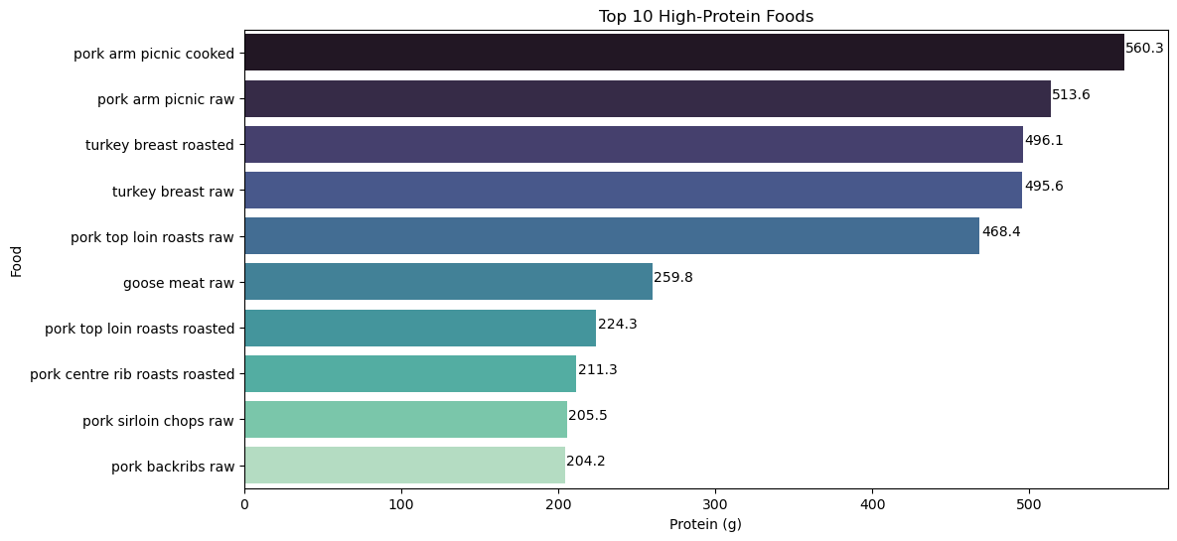
The calories versus protein scatter plot helped distinguish foods that are calorie-dense but nutritionally weak from foods that are calorie-efficient and protein-rich. This type of chart supports recommendation scoring design.
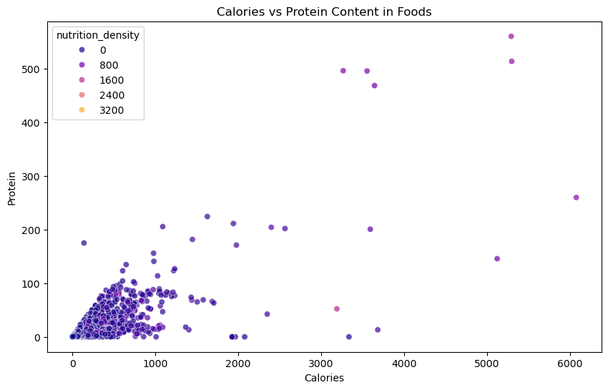
The macronutrient comparison heatmap was especially useful because it compared foods across protein, fat, carbohydrates, fiber, and sugars using both values and color intensity. This made it easy to see which foods are balanced, which are sugar-heavy, and which are protein-dominant.
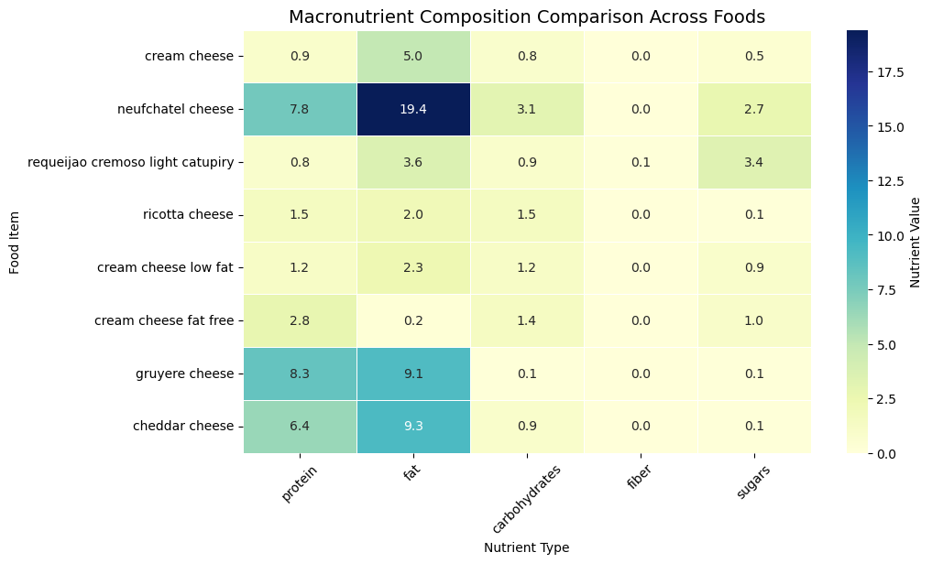
The clustered nutrient heatmap revealed which nutrients tend to move together. This is useful for future clustering or food embedding models, where foods may be grouped based on shared nutrient signatures.
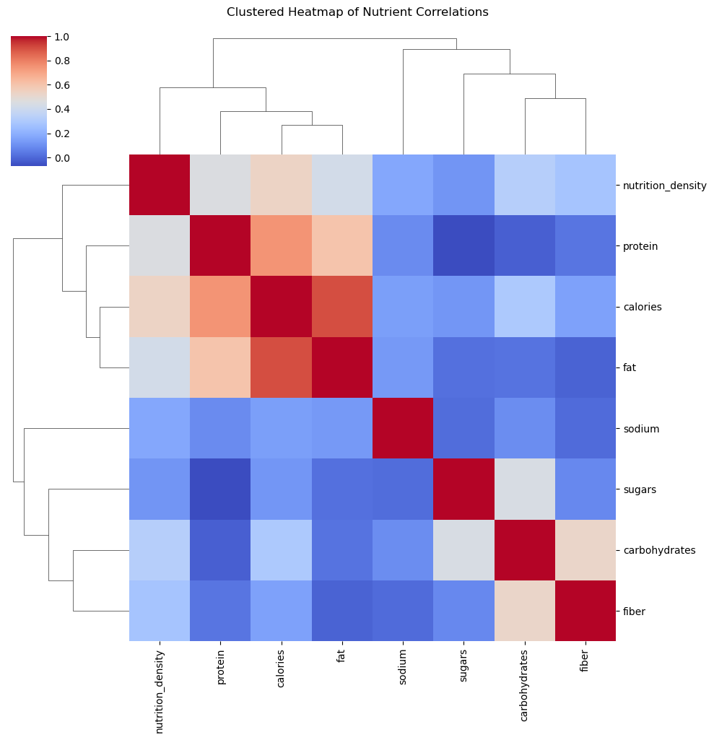
6.3 Recipe Dataset EDA
The recipe dataset added cultural and meal-level context.
The top cuisines chart showed that the recipe set covers a broad range of cuisines, including Argentinian, Swedish, Japanese, Nigerian, Korean, Peruvian, Ethiopian, Thai, French, and others. This diversity is valuable because it prevents the recommendation system from being limited to one narrow food culture.
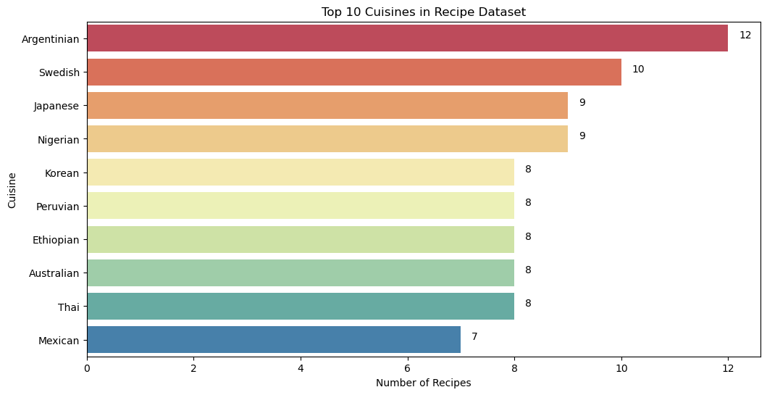
The cooking time distribution chart showed that most recipes are concentrated at lower to moderate cooking times, with a few long-tail outliers reaching up to 720 minutes. This matters for recommendation because users often care about convenience as much as calories.
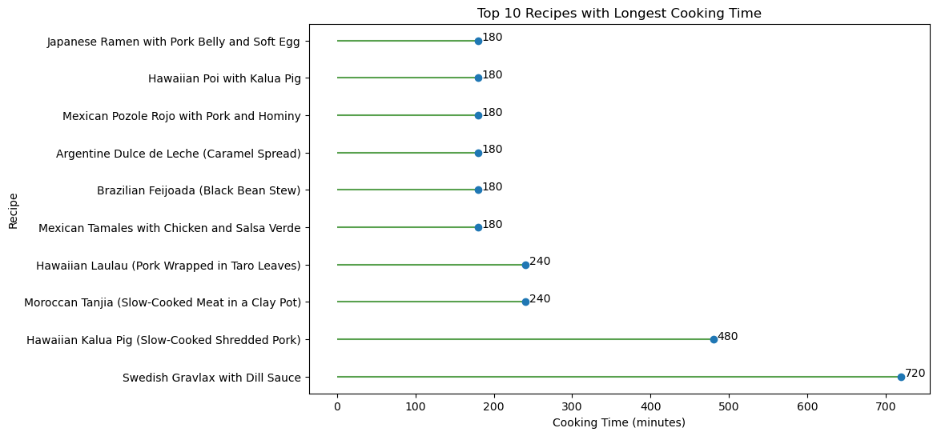
The calories per serving distribution showed broad variation from very light dishes to energy-dense meals. This makes the dataset suitable for calorie-range recipe matching.
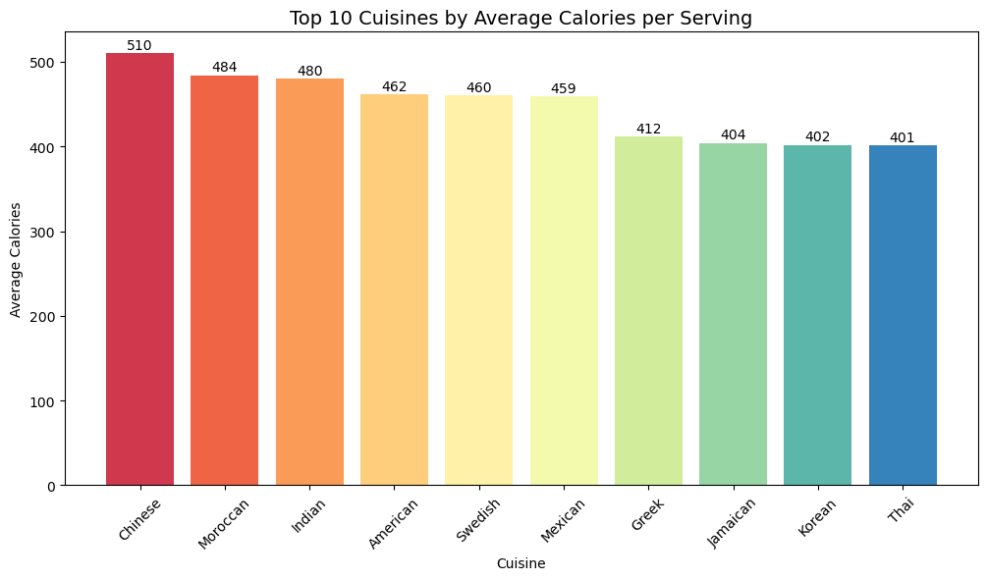
Overall, the EDA phase did more than summarize the data. It shaped the next steps by identifying key predictive variables, useful nutrition criteria, and recipe characteristics that later informed feature engineering and recommendation ranking.

7. Feature Engineering
Feature engineering was performed separately for the three datasets.
7.1 Calorie Dataset Features
New variables included BMI and heart rate intensity. BMI captures body composition in a more useful way than weight alone, while heart rate intensity normalizes effort relative to age.
Originally, two additional features were created: calories_per_min and calorie_efficiency. Although they appeared informative at first, both depended directly on the target variable calories. This later became a critical issue because it introduced target leakage.
7.2 Nutrition Dataset Features
Several ratio-based features were engineered for recommendation:
- protein ratio
- fat ratio
- carbohydrate ratio
- sugar ratio
- fiber density
- protein density
These features were especially important because recommendation systems rarely rely only on raw calorie values. Nutrient density and balance are more meaningful for ranking and personalization.
7.3 Recipe Dataset Features
Recipe-level features included:
- total time
- ingredient count
- calorie density
These help estimate preparation complexity and meal practicality. A fast, lower-complexity recipe may be more recommendable than a high-effort one with similar calories.

8. Machine Learning Modeling
The main modeling task was regression, with calories as the target variable.
Three models were trained and compared:
- Linear Regression
- Random Forest Regressor
- Gradient Boosting Regressor
Performance was evaluated using MSE, RMSE, R², and Adjusted R².
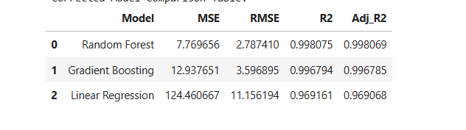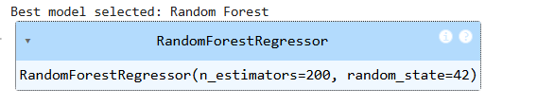
8.1 Initial Modeling Issue: Target Leakage
An important methodological issue emerged after the first recommendation test. The system predicted only 1 calorie for a realistic exercise profile, which immediately signaled a problem.
The cause was target leakage. Two engineered features, calories_per_min and calorie_efficiency, were derived using the target variable itself. Including them in the model made the training process artificially strong but invalid for real prediction. When these variables were unavailable at inference time and set to zero, the model failed.
This was a crucial discovery because it demonstrated the importance of real-world validation, not just metric-based success.
8.2 Corrected Modeling
After removing the leaked features, the models were retrained using only valid predictors. This correction made the system methodologically sound and produced realistic calorie estimates.
The corrected comparison showed that Random Forest performed best overall, with the lowest error and the highest explanatory power among the tested models. Gradient Boosting also performed strongly, while Linear Regression provided a useful baseline but was less flexible than the tree-based models.
This outcome is expected because calorie expenditure depends on nonlinear interactions among duration, heart rate, age, body temperature, and body composition. Random Forest can model those nonlinearities more effectively than a simple linear model.

9. Model Explainability
Interpretability was addressed through feature importance using the Random Forest model.
The most influential features were those directly tied to exercise intensity and physiology, such as:
- duration
- heart rate
- body temperature
- BMI or body-condition-related measures
- heart-rate intensity
This ranking is meaningful because it aligns with exercise science intuition. Calories burned should depend heavily on how long the activity lasted, how intense it was, and the physiological state of the individual.
The actual versus predicted plot showed that predictions tracked observed calorie values closely, supporting the model’s usefulness.
The residual plot showed that prediction errors were generally centered around zero, which is a good sign for model stability.
This explainability section strengthens the project because it moves beyond prediction and addresses the professor’s expectation for responsible, interpretable AI.

10. Recommendation System
The recommendation system is the most application-oriented part of the project.
10.1 Logic
The workflow is:
- Accept user input
- Predict calorie need or calories burned using the corrected best model
- Search food items near the predicted calorie range
- Rank foods using a nutrition-based recommendation score
- Search recipes near the target calorie range
- Rank recipes by calorie suitability, total time, and complexity
10.2 Food Ranking Score
The food recommendation score rewards:
- high protein density
- high fiber density
- high nutrition density
and penalizes:
- high sugar
- high sodium
This scoring logic is reasonable for a general-purpose healthy recommendation system, though it can be further personalized in future work.
10.3 Recipe Ranking
Recipes are filtered by calories per serving and ranked using a score that favors:
- lower total time
- fewer ingredients
- calorie suitability
This is useful because meal recommendation is not just about calories. A system that ignores cooking effort may recommend technically appropriate but impractical meals.
10.4 Result Validation
After the leakage fix, the example user profile produced a predicted calorie value of approximately 154.13, which is realistic for a 30-minute moderate exercise session. The foods returned by the system fell within the expected calorie range and included protein-rich, nutritionally dense options such as high-protein dairy, tofu, fish, and egg substitutes. Recipes also fell into the correct range and offered calorie-matched meal suggestions.
This confirms that the recommendation engine is now functioning correctly and is aligned with the predictive model.

11. Key Findings
Several findings stand out from the project.
First, exercise duration and heart rate are among the strongest predictors of calorie expenditure. This reinforces both the model logic and the EDA findings.
Second, food-level recommendation works better when based on nutrition density and macro ratios rather than raw calories alone. A pure calorie filter would return many weak recommendations, while density-aware scoring returns nutritionally stronger results.
Third, recipes add important practical value. A user does not only need ingredients; they also need meal options that fit calorie goals and preparation constraints.
Fourth, the leakage issue was one of the most valuable lessons in the project. It improved the scientific quality of the work and demonstrated that strong-looking metrics are not enough unless the features are valid at prediction time.

12. Responsible AI and Limitations
This project includes clear AI value, but it also has limitations that should be acknowledged.
The calorie model estimates energy expenditure from available variables, but it does not account for metabolism, medical conditions, body composition details, or long-term health goals. Therefore, it should be interpreted as a decision-support model, not a medical system.
The recommendation logic uses a fixed scoring formula. Different users may prioritize different outcomes, such as muscle gain, low sodium, low sugar, vegetarian preference, or cultural familiarity. A future system should personalize those weights.
The recipe dataset is relatively small compared to the food dataset, so meal recommendations are less comprehensive than ingredient recommendations.
The food dataset contains some foods with extreme nutrient values, which may reflect concentrated products, supplements, or unusual items. A more production-ready version should incorporate food category constraints and serving-size normalization.
Despite these limitations, the project is still strong because it clearly separates prediction, ranking, and interpretation, and because it identifies where future improvements are needed.

13. Future Plan and Phase-2 Expansion
This project already includes a functioning predictive and recommendation core, but there is strong potential for expansion.
13.1 Interactive Dashboard
The next major step is building an interactive nutrition dashboard, likely in Streamlit, Plotly Dash, or Tableau. The dashboard should include:
- user input panel for age, gender, height, weight, duration, heart rate, and body temperature
- predicted calories display
- recommended foods table
- recommended recipes table
- macro comparison charts
- nutrition density visuals
- cuisine and recipe filtering
- responsible AI section explaining model limits
This will complete the third project goal and transform the notebook into a usable AI prototype.
13.2 Advanced Models
Future model development should include:
- XGBoost or LightGBM for stronger gradient-based regression
- cross-validation instead of one train-test split
- hyperparameter tuning using GridSearchCV or RandomizedSearchCV
- feature selection or permutation importance
- SHAP values for local explainability
These would strengthen both predictive accuracy and research rigor.
13.3 Advanced Recommendation AI
The current recommendation logic is rule-based plus model-driven. Future work can make it more AI-rich by adding:
- KNN-based food similarity
- clustering foods by nutrient profiles
- meal-plan generation across breakfast, lunch, and dinner
- user-preference weighting
- dietary restriction filtering
- cuisine-aware personalization
- collaborative or hybrid recommendation logic
This would move the system toward a more sophisticated personalized recommender.
13.4 AI Application Extensions
The project can also evolve into broader AI applications such as:
- fitness app integration
- wearable device input for real-time heart rate and activity monitoring
- meal recommendation chatbot
- health assistant interface
- grocery planning from recommended meals
- weekly personalized nutrition planning
These directions make the project not only an academic submission but also a realistic prototype for applied AI in nutrition technology.

14. Conclusion
This project successfully developed an AI-Powered Personalized Nutrition Recommendation System that combines regression modeling, food intelligence, recipe support, and explainability into one coherent workflow. The system predicts calorie needs from physiological and exercise data, translates those predictions into food and recipe recommendations, and lays the groundwork for a future interactive dashboard.
The work is especially strong because it did not stop at model training. It included rigorous auditing, careful cleaning, strong visual analysis, feature engineering, leakage correction, model comparison, explainability, and application design. The final system is not only technically functional but also methodologically thoughtful.
With dashboard integration, advanced tuning, and richer personalization logic, this project can develop into a highly compelling AI application for nutrition support, lifestyle planning, and personalized food recommendation.

